Single threaded

JS is a single threaded programming language. It means one set of instruction is executed at a time. (It only has one callstack)

So JS is synchronous, one thing at a time.

Problems in Synchronous code

1. Difficult for long running task
   1. I need to wait the function execute finish before I can do other actions (Need to wait callstack finish executing)

In fact, it is not only JS engine running, one more thing is JS runtime in today modern day

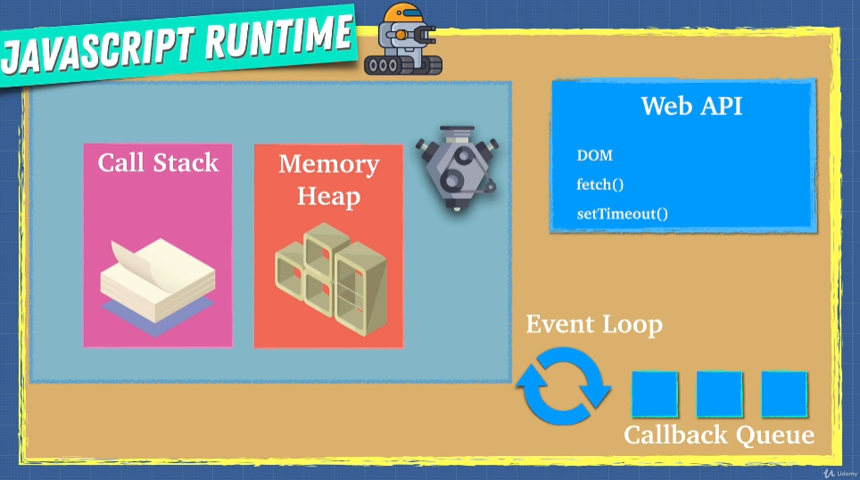

JS runtime use web API communicating (Web API comes with the browser – Not native JS!!!) in background and like telling JS engine hey I am back with some data. Web APIs can do variety of things like send http, dom events, delay execution, caching etc.

Check Window object in console. These web API is what we called Asynchronous.

Here’s the process:

1. Callstack as soon as it met code from Web API which is not for JS, tell Web API do it in background (moved away from callstack first)
2. After Web API done, event loop is queue up from that. Event loop tell callstack I have something for you
3. Event Loop always run to see is callstack empty
4. As soon as it sees callstack empty, it pushes to the stack from callback

